Chatify: Real-Time Chat Application / Mini Project (KCS 752)
A Report Submitted in partial fulfilment for the award of
Degree of Bachelor of Technology
In
Computer Science & Engg.
Batch 2021 – 25
Submitted By:
Vishesha Sanadhya
Roll No. 2100650100116



Submitted To:
Dr Durga Puja, AP CSA

(Mini Project / Internship Assessment)
(KCS-752)
[Session: 2024-2025]

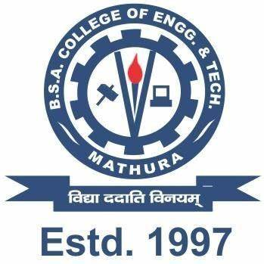
B.S.A. COLLEGE OF ENGG. & TECH., MATHURA
EST. & GOVERNED BY SHRI AGRAWAL SHIKSHA MANDAL

B.S.A College of Engineering & Technology, Mathura
EST. & Governed By: SHRI AGRAWAL SHIKSHA MANDAL (Regd.), Mathura

Department of Computer Science & Applications
DECLARATION

This is to certify that the Report Entitled “Real-Time Chat Application” which is being submitted in partial fulfilment of the requirement for the award of degree B. Tech in Computer Science and Engineering to B.S.A. College of Engineering & Technology, Mathura comprises only original work and studies carried out by the students themselves. The matter embodied in this work has not been submitted for the award of any other degree.

Date: 25-09-2024 Vishesha Sanadhya (2100650100116)

